2-4 Circle Graphs Key

Circle Graph – is used to display how a whole is divided.

- The sectors of the circle represent parts of the data.

- A circle graph can provide a very good visual representation of a set of data because the size of the slices varies visibly compared to the whole.

- More readily see proportional amounts.

- Circles graphs are less likely to be used to display misrepresenting data unless important data is omitted.

Example 1) The following circle graph shows how many people in Maxine’s office building get to work. There are 350 people working in the building.

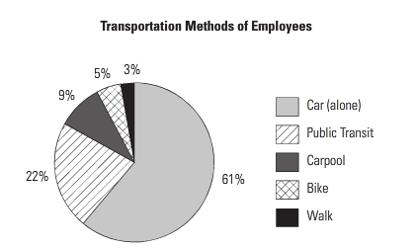

a) What percentage of the people walk to work/ How many people does his represent/
The graph shows that 3% of people walk to work. Calculate 3% of 350.
1) Change the percent to a decimal
2) Multiply that decimal by the total amount
0.03 x 350 = 10.5
Therefore, 11 people walk to work.
b) What percentage of people come to work in a car? How many people is this?
You will need to cinsider those who drive alone and those who carpool. 61% come by car alone, 9% carpool, therefore 70% come to work by car. Calculate 70% of 350.
0.7 x 350 = 245
245 people come to work by car.
c) Consider those who carpool, walk, or bike. Is this more or less than the number who take public transit? How many more or less?
The graph shows that 9% carpool, 3% walk, and 5% bike, for a total of 17%. This is less than the number who take publc transit (22%).
Calculate 17% of 350.
0.17 x 350 = 59.5
Therefore, 60 people carpool, walk or bike to work.
Calculate 22% of 350.
0.22 x 350 = 77
77 people use public transit to get to work.
Calculate the difference: 77 – 60 = 17.
There are 17 fewer people who carpool, walk or bike than take transit.

Example 2) Jasmine surveyed students at her college to find out how they commute to school. The results are shown in the table below. Create a circle graph of the data. 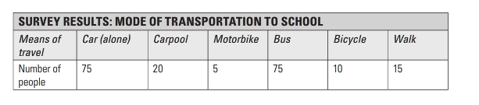
STEP 1: Calculate what proportion of the total data is represented by each category:

Total: 75 + 20 + 5 + 75 + 10 + 15 = 200

Car Alone – 75 ÷ 200 = 0.375
Carpool - 20 ÷ 200 = 0.1
Motor Bike - 5 ÷ 200 = 0.025
Bus – 75 ÷ 200 = 0.375
Bicycle - 10 ÷ 200 = 0.05
Walking - 15 ÷200 = 0.075

STEP 2: Calculate how many degrees of a circle are presented by each category:

Car Alone 0.375 x 360 = 135°
Carpool 0.1 x 360 = 36°
Motor Bike 0.025 x 360 = 9°
Bus 0.375 x 360 = 135°
Bicycle 0.05 x 360 = 18°
Walking .075 x 360 = 27°

STEP 3: Draw a circle and a radius. Use your protractor to measure the degrees of each section.

