2-4 Assignment: Circle Graphs

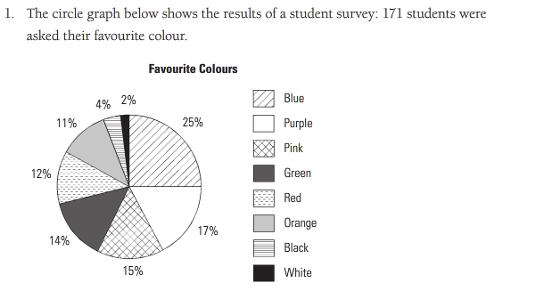

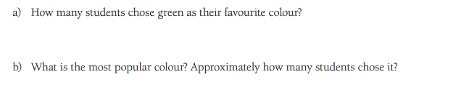

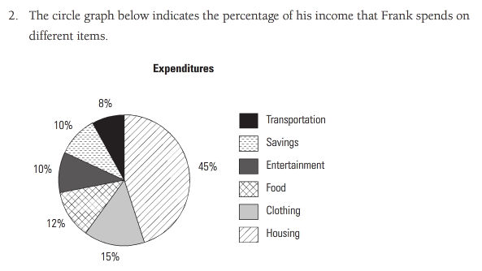

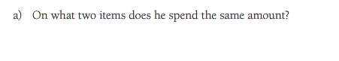

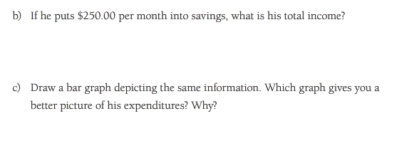

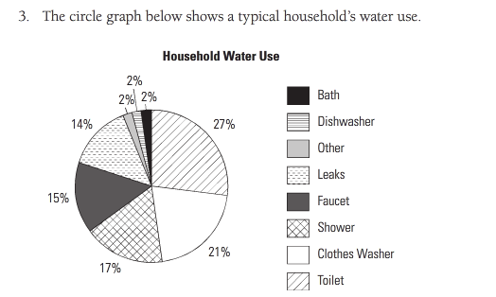

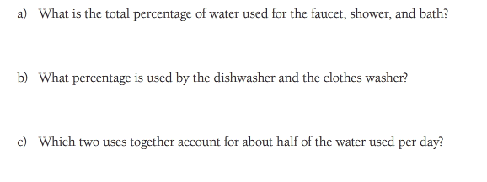
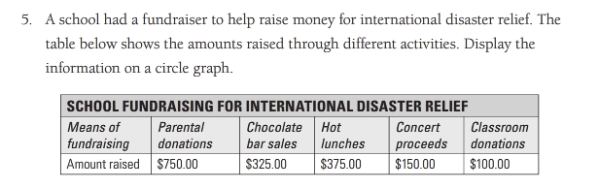
STEP 1: Calculate what proportion of the total data is represented by each category:

Total:
Parental Donation:
Chocolate Bar Sales:
Hot Lunches:
Concert Proceeds:
Classroom Donations:

STEP 2: Calculate how many degrees of a circle are presented by each category:

Parental Donation:
Chocolate Bar Sales:
Hot Lunches:
Concert Proceeds:
Classroom Donations:

STEP 3: Draw a circle and a radius. Use your protractor to measure the degrees of each section.

