2-3 Histograms Notes Key

Histogram – Is like a bar graph except that it is used to represent continuous data so the bars are touching.

- The width of each bar represents a range of numbers.

- the bars on a histogram are usually labeled with a lower and upper boundary.

Lower Boundary – the lowest value of the interval on a histogram

Upper Boundary – the highest value of the interval on a histogram

Example 1) The histogram below shows the number of airplanes scheduled to arrive at the Calgary International Airport on a particular day.

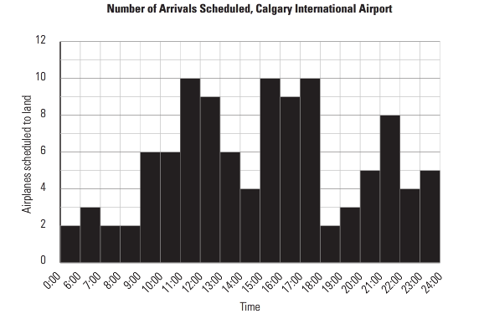

a) How many airplanes are scheduled to arrive between 2:00 pm and 3:00 pm?
Four airplanes are scheduled to arrive between 2:00 pm and 3:00 pm (14:00 – 15:00)
b) What are the busiest times at the airport? How many airplanes are scheduled to arrive at these times?
The busiest times are between 11:00 and 12:00, between 15:00 and 16:00, and between 17:00 and 18:00. Ten airplanes are scheduled to arrive during each of these timeframes.
c) What is the quietest time?
The quietest time at the airport is between midnight (24:00) to 6:00 am. Although it looks like 7:00 to 8:00 and 8:00 to 9:00 are just as quiet, with only two arrivals as well, the interval for idnight to 6:00 am is larger than the others.
d) Are any airplanes scheduled to arrive between 4:00 am and 5:00 am?
The histogram shows that two planes arrived between midnight and 6:00 am but you cannot be sure if one arrived at 4:00 am.

Example 2) The histogram belown shows the salaries of the employees at Supersonic Businesses Inc.

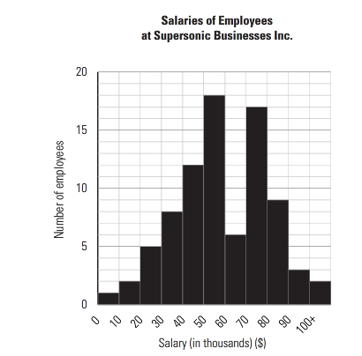

a) How many employees earn over $100 000.00?
2
b) How many employees earn between $30 000.00 and $50 000.00?
20
c) Do individuals have a good chance of getting a good salary with this company? Explain you answer.
16 people get paid under $40 000 per year, while 92 people get paid above $40 000 per year. Most likely you would have a good chance of getting a good salary.

