2-3 Notes: Histograms

Histogram – Is like a __________ graph except that it is used to represent __________ data so the bars are touching.

- The ____________ of each bar represents a range of numbers.

- the bars on a histogram are usually labeled with a lower and upper boundary.

Lower Boundary – the ___________ value of the interval on a histogram

Upper Boundary – the ___________ value of the interval on a histogram

Example 1) The histogram below shows the number of airplanes scheduled to arrive at the Calgary International Airport on a particular day.

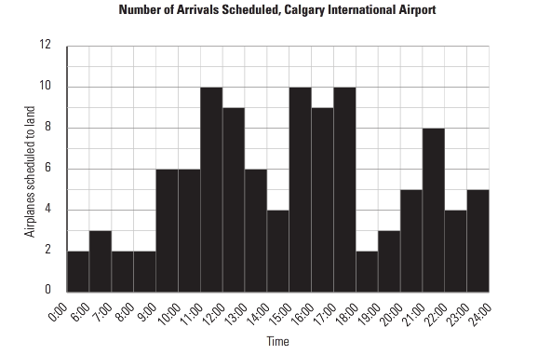

a) How many airplanes are scheduled to arrive between 2:00 pm and 3:00 pm?
_________________________________________________________________

b) What are the busiest times at the airport? How many airplanes are scheduled to arrive at these times?
____________________________________________________________________________________________________________________________________

c) What is the quietest time?
____________________________________________________________________________________________________________________________________

d) Are any airplanes scheduled to arrive between 4:00 am and 5:00 am?
____________________________________________________________________________________________________________________________________

Example 2) The histogram below shows the salaries of the employees at Supersonic Businesses Inc.

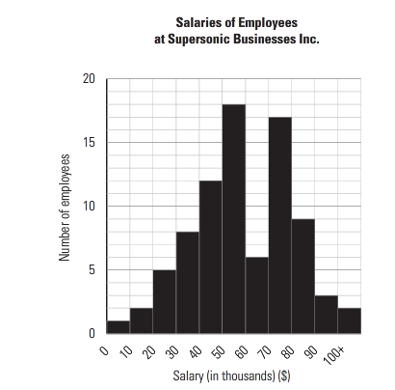

a) How many employees earn over $100 000.00?
_______________

b) How many employees earn between $30 000.00 and $50 000.00?
_______________

c) Do individuals have a good chance of getting a good salary with this company? Explain you answer.
____________________________________________________________________________________________________________________________________

