2-2 Notes: Bar Graphs NOTES

Bar Graph – a graph that used to display ____________ data, using regular bars

Discrete Data – data that can only have certain ____________ values

Ex. _______________________________________________
_________________________________________________
 The bars on a bar graph can either be ____________ or ____________, and have spaces between them

 Set the scale, label the axes, and give the graph a title the same way you would for a broken line graph.

Important Note: The ____________ and the starting point on the axes affect the way a graph is interpreted. By increasing or decreasing the scale, or by changing the starting point on the axis, you can make the viewer see the data a certain way.

Example 1) Which graph is misleading?

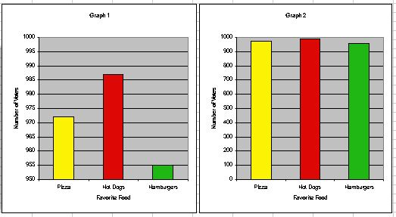

_________________________________________________
_________________________________________________

Example 2) The 2001 Canadian census data listed the following approximate populations of various cities, to the nearest thousand.
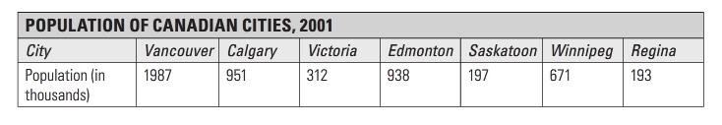
Display the data on a bar graph.
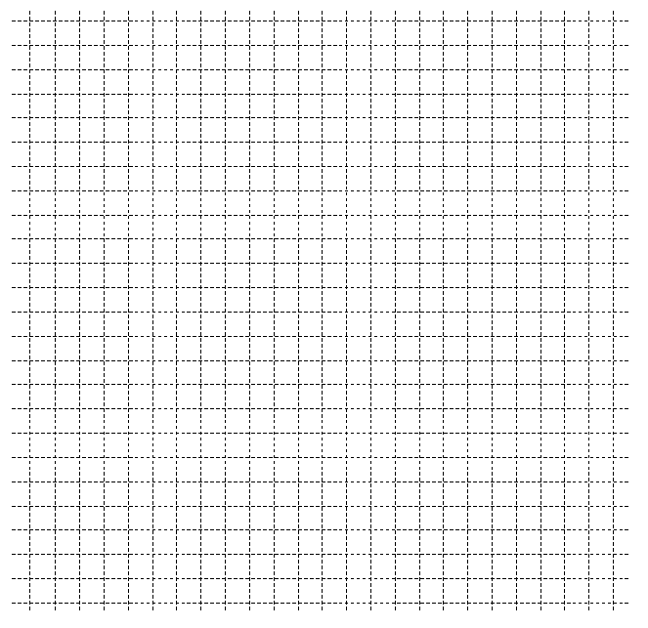

You may want to arrange the cities by height because it gives a more visual representation of the ranking of the populations.

Note: Some data that can be represented using either a vertical bar graph or a horizontal bar graph can also be shown on a broken line graph. Each type of graph has its advantages for displaying certain kinds of data.

Example 3) The following table show the approximate population of Moose Jaw, Saskatchewan, from 1980 to 2005.
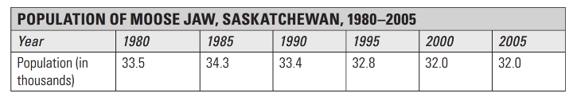

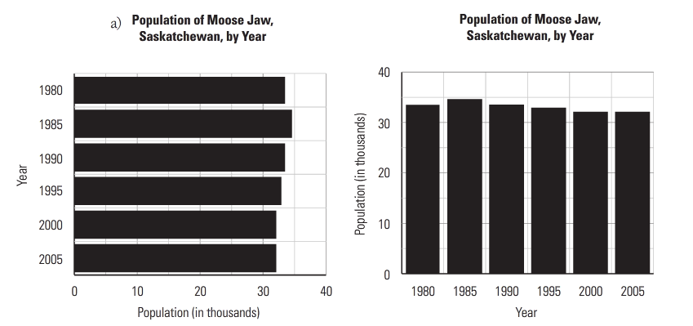
a) Which graph is a better representation of the data? Why?
_________________________________________________
_________________________________________________
b) What is the trend in population size in Moose Jaw?
_________________________________________________
c) Give the data on a broken line graph, do you think the vertical bar graph or broken line graph is a better representation of the data?
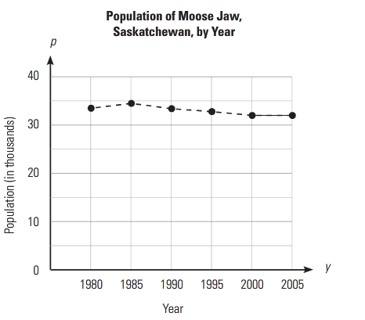

_________________________________________________
_________________________________________________

Double Bar Graph:
- The double bar graph is an effective means of ____________ sets of data about the same places or items.

Example 4) Roger is a real estate agent in Red Deer, Alberta. The graph below compares the average house prices of new single-family homes and resale (not new) single-family homes.
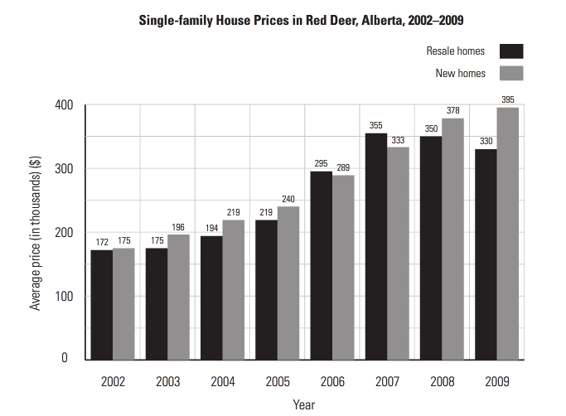
a) What was the average price of a new home in 2005?
_________________________________________________
b) Between what years was there a drop in the price of resale-single-family homes?
_________________________________________________
c) What is the general trend in the differences in prices (which cost more/less) of the two types of units? In which years was this not so?
_________________________________________________
_________________________________________________

Stacked Bar Graph:
- When comparing data, you can sometimes use a ____________ bar graph.
- In this type, each type of item is represented by a difference ____________, but instead of being drawn side by side, the bars are stacked on top of each other.
- It is important that the bars are stacked in the same ____________.

Example 5) Using the data from example 4. What is less obvious on a stacked graph than on the double bar graph?






