Science 10 – Chemistry  Bonding & Naming | Name:  Date:  Block:

Bonding
- Relationship between ____________________________
- Only ____________________________________ interact

Ionic Bonding
- Electron ___________________ and ___________________.
- Between ___________________ and ___________________. (ie.

- Na (to achieve ___________________ ____________ ___________________) becomes _______.
- Cl (to achieve ___________________ _____________ ___________________ ) becomes _______.

Covalent Bonding
- Electron ___________________ .
- Between ___________________.

What is a Compound?  - A substance composed of two or more ___________________ that have been _______________ united.  What is a Chemical Formula?  - A way of express the _________________ that make up a _________________________________________  - Always _____________________________  - Example 1: H₂O # of atoms:  - Example 2: CH₄ # of atoms  - Example 3: NH₄Cl # of atoms:  - Example 4: (NH₄)₃PO₄ # of atoms: | 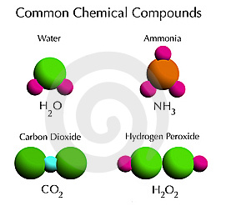

Naming Simple Ionic Compounds:

- Example 1: NaCl
- Identify the positive and negative ion

- What is the name of the positive ion?

- What is the name of the negative ion? – change the ending to “ide”

- Example 2: MgBr₂ (when naming, ignore the subscript “2”)
- Identify the positive and negative ion

- What is the name of the positive ion?

- What is the name of the negative ion? – change the ending to “ide”

Practice Problems: (answer these questions in your Class Starter Binder)

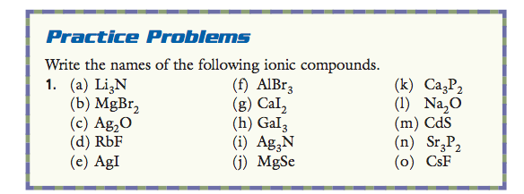
Writing Formulas of Simple Ionic Compounds:
- Example 1: Barium Chloride
- This is where we have to take note of the ______________________ of each ion
- When we write our formula, we ______________________ include the charges
- What is the charge of barium?

- What is the charge of chlorine?

- To write the formula, we must balance the charges.

Positive | Negative
Overall: | Overall:

- Example 2: Magnesium oxide
- What is the charge of magnesium?

- What is the charge of oxygen?

- To write the formula, we must balance the charges.

Positive | Negative
Overall: | Overall:

- Example 3: Strontium Phosphide
- What is the charge of strontium?

- What is the charge of phosphorus?

- To write the formula, we must balance the charges.

Positive | Negative
Overall: | Overall:

Practice Problems: (answer these questions in your Class Starter Binder)

