Photosynthesis and Cellular Respiration
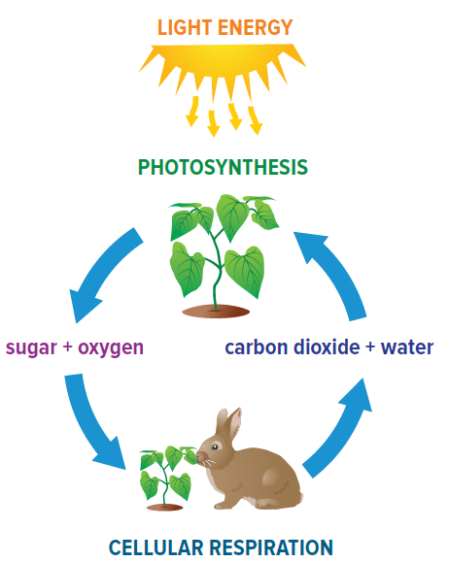
Photosynthesis– the process by which plant cells convert ________________________________ and _________ into _______________ and ________________. This occurs in the ________________.

carbon dioxide + water + sunlight (energy) → sugar + oxygen
Cellular respiration – how ___________________________ get their ____________. This reaction occurs in the ______________________________.

sugar + oxygen → carbon dioxide + water + energy
What do you notice about the two equations above? __________________________
Complete the table to compare photosynthesis and cellular respiration. Refer to the information and figure above to help you complete the table.
 | Photosynthesis | Cellular Respiration
Type of cell(s) it takes place in
Type of organelle it is associated with
Reactants
Products
Is energy stored or released?

- What are the similarities between cellular respiration and photosynthesis?

- Do you see any differences/relationships between photosynthesis and cellular respiration

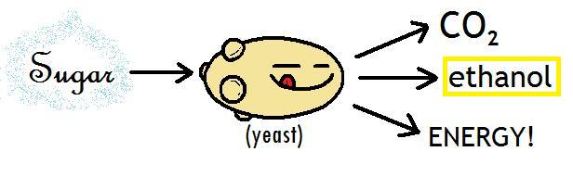
Note: When there is no _____________ present, yeast and bacteria do a process called __________________ in which ______________ is converted to ______________________, _________________ and ______________. This was the focus of our last lab!

