Science 8  Cell Unit Review | Name:  Date:  Block:

Are you Beginning, Developing, or Accomplished at each of the following learning goals? Go through the check list and mark each row as “B”, “D”, or “A” based on your level of understanding. Use the “B”s as areas to focus on when you’re studying!
KNOW
B | D | A | LEARNING GOAL
 |  |  | I can name the characteristics of living things
 |  |  | I can describe the three principles of the cell theory
 |  |  | I can explain the main differences between prokaryotic & eukaryotic cells
 |  |  | I can describe the functions of eukaryotic (plant & animal) cell structures
 |  |  | I can describe how to focus a microscope by referring to specific parts
 |  |  | I can define the term microorganism
 |  |  | I can define pathogen and give examples of different microorganisms that are pathogens (or not)
 |  |  | I can describe how pathogens spread
 |  |  | I can explain what the first, second, and third lines of defense are in the body
 |  |  | I can describe the difference between a vaccine and an antibiotic
 |  |  | I can describe the difference between an epidemic and a pandemic

DO
B | D | A | LEARNING GOAL
 |  |  | I can identify if something is living or non-living using the characteristics of living things
 |  |  | I can identify if a cell is prokaryotic or eukaryotic if given its characteristics
 |  |  | I can identify cell structures on diagrams of plant, animal, and bacterial cells
 |  |  | I can compare and contrast the structure of plant, animal, and bacterial cells
 |  |  | I can focus a microscope & calculate total magnification with a given objective lens
 |  |  | I can compare the first and second lines and third lines of defense
 |  |  | I can explain how pathogens, antigens, antibodies, and white blood cells interact as part of the immune response

- List the 5 characteristics of living things.

  - It has to respire (breathe or exchange gas)

  - It has to be composed of cells

  - It has to take in nutrients.

  - It has to produce waste

  - It has to respond to stimuli (react to it’s environment)

  - It has to reproduce

  - It has to have a lifespan

  - It has to grow

- An explorer from another galaxy has arrived on Earth and believes cars are living things.
  - Which characteristic(s) of a living thing would a car show?

It respires and produces waste

  - How would you explain that a car is not a living thing?

Everything else!

- The coarse focus knob on a microscope should be used with which objective lens(es)?

Low power and if you are very careful Medium power!

- Label the parts of the microscope.
a. Ocular Lens  b. Rotating Nosepiece  c. Objective Lens  d. Stage  e. Light Source  f. Course Adjuster  g. Fine Adjuster | 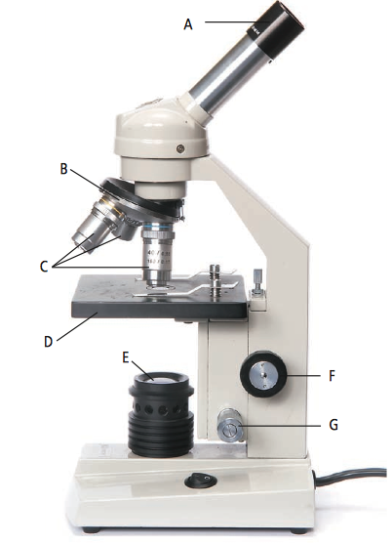

- Animal cell vs. plant cell.
  - Which two organelles do plants have that animals do not?
Cell Wall and Chloroplast

  - What are their functions?
Chloroplast is used to generate food (sugar), the Cell Wall provides a protective layer for the cell.

- Summarize the 3 key points of the cell theory.
- All known living things are made up of one or more cells.
- All living cells arise from pre-existing cells by division.
- The cell is the fundamental unit of structure and function in all living organisms.

- What is the difference between a prokaryotic and eukaryotic cell?

Eukaryotic (animal and plant) cells have a nucleus, Prokaryotic cells do not.

- Describe one difference between bacteria and viruses.

Bacteria can be treated with antibiotics and viruses cannot.

- Animal cells do not have chloroplasts. Explain why.

Plants cells produce their own food (sugar) through photosynthesis and therefore need chloroplasts to collect sunlight. Animal cells are not capable of producing their own food and therefore have no use for chloroplast.

- What is a pathogen?

Pathogens are microorganisms, such as bacteria and viruses, that can cause illness.

- What is the difference between epidemic and pandemic?

Epidemics are when a disease infects more people than it normally does or spreads to an area it is not normally found while a pandemic is an epidemic of world-wide proportions.

- Antibodies are produced in response to antigens. What are anitgens and antibodies and where do they come from?
Antigens are produced by invaders, such as pathogens, and they signal the production of antibodies which are large proteins that attack and kill invaders into the body. Each antibody is specific to an invader/pathogen and once your body has produced the antibodies it can prevent another attack.

- What is a vaccine and what is an antibiotic?
A vaccine is a substance used to stimulate the production of antibodies and promote immunity to pathogens. Vaccines are made in a variety of ways and some examples of types of vaccines are: sub-unit, attenuated, and inactive vaccines.
An antibiotic that inhibits the growth or destroys certain types of microorganism, such as bacteria. Antibiotics only work against living things

- Identify the follow cells as either a plant or animal cell and then label the organelles.
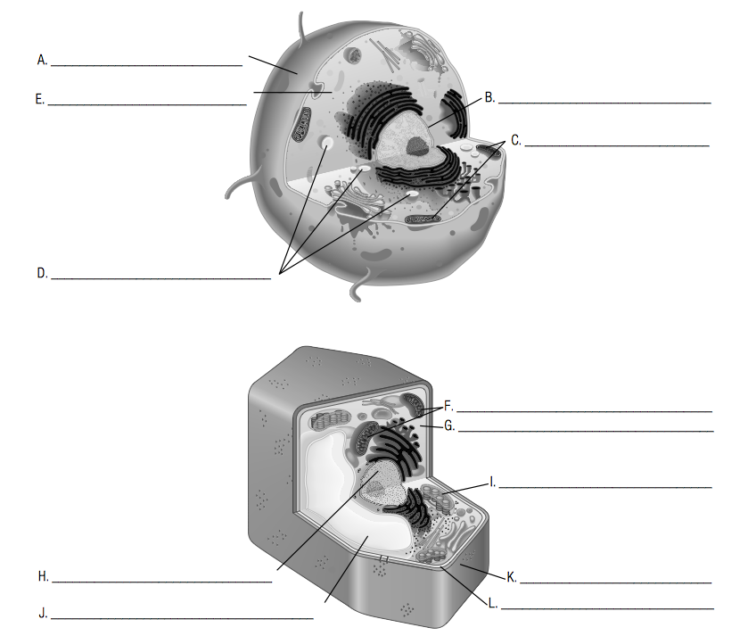

First one – Animal Cell
  - Cell Membrane
  - Nucleus
  - Mitochondria
  - Vacuole
  - Cytoplasm

Second one – Plant Cell
  - Mitochondria
  - Cytoplasm
  - Nucleus
  - Chloroplast
  - Vacuole
  - Cell Wall
  - Cell Membrane

- What are the body defenses?

  - Primary (first) – Physical barriers such as your skin

  - Secondary (second) – the circulatory system (white blood cells (type of phagocyte) attack pathogens)

  - Tertiary (third) – The immune system

