Science 8 – Unit 2 - Optics Study Guide Name:_________________________ Block: _______
- What is the difference between transparent, translucent and opaque?

- List the 7 regions of waves found in the electromagnetic spectrum:

  - Which one can we see? ________________
  - Put them in order from highest to lowest frequency

  - Put them in order from largest to smallest wavelength

  - What is the relationship between frequency and wavelength in the electromagnetic spectrum?

- List the visible colours from lowest to highest frequency

- What is the difference between the wave model and the ray model of light?

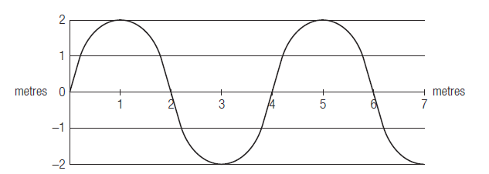
- Identify each of the following on the following diagram: amplitude, trough, crest, rest position and wavelength:

- What is frequency and what unit is it measured in?

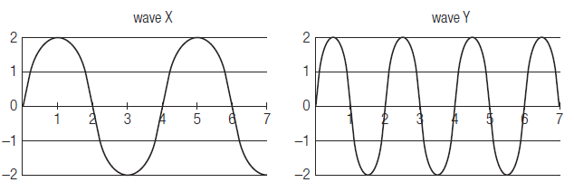
- Which of the following has high frequency and which one has a higher wavelength.

- For each diagram (above) determine the wavelength and the amplitude (the units are in metres).

Wave X: ______________ Wave Y: ____________
- What is reflection?

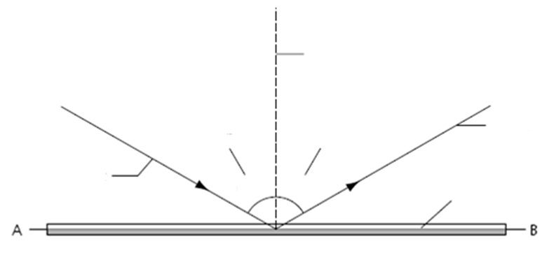
- Label the following diagram:

- What is the physical difference between a plane mirror, convex mirror and concave mirror. (include diagrams)
Plane | Convex | Concave

- What is refraction?

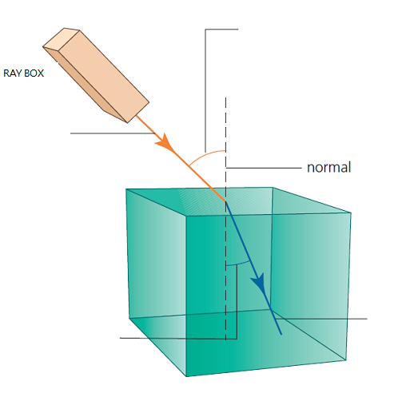
- Label the diagram to the right:

- What is the difference between refraction and reflection?

- What is the difference between a lens and a mirror?

- What happens to the speed and direction of light as it travels from a dense material to less dense material?

- When looking at a fish under water, why does it appear to be in a different location than it actually is?

- Compare and contrast convex and concave lenses:
1st Draw a diagram of light hitting a: (make sure to label the focal point for the Convex Lens)
2nd List some uses of each
Convex Lens | Concave Lens
Uses | Uses

If you complete this whole document and then read it over and quiz yourself – you should do very well on the unit test.

