Science 8  Earth Science Unit Review | Name:  Date:  Block:

- List the five pieces of evidence that support Continental Drift Theory.

- What land mass does Pangaea refer to?

- Complete the following table with the layers of the Earth:
Layer | State

- What is a tectonic plate and why does Earth have moving plates while Mars does not?

- What is the Mid-Atlantic Ridge? Where is it found? Identify the Mid-Atlantic Ridge on the map below.

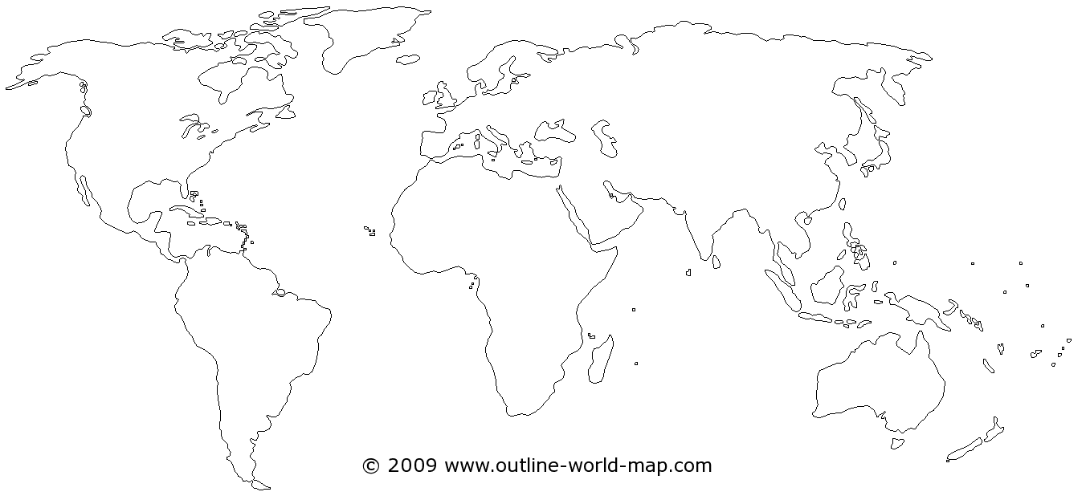

- Use the diagram of the Mid-Atlantic Ridge below to answer the questions that follow:
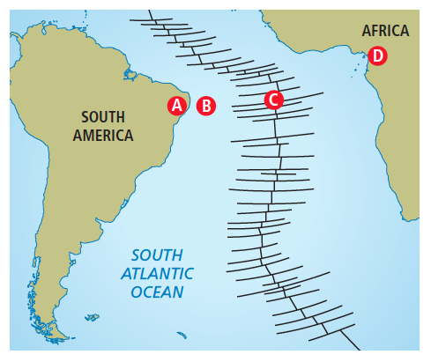 | - How does the thickness of the crust at location A compare to the thickness of the crust at location B?  - Where is the youngest rock located?  - How does the age of rock at A compare to the age of rock at D?  - Where is magma most likely to be rising to the surface?

- What is seafloor spreading? Explain this process using the terms “ridge push” and “slab pull”.

- What is a geologic hot spot? What happens when a tectonic plate passes over a hot spot?

- Describe the theory of plate tectonics.

- Describe the age of rocks relative to their distance from an ocean ridge at a divergent plate boundary.

- Name and draw the three main types of tectonic plate boundaries.

- Why does subduction occur at some kinds of tectonic plate boundaries but not at others?

- Name a mountain range produced by continental-continental plate convergence.

- The diagram below is a cross-section showing different types of tectonic plates and geological features.
________ Continental-continental divergence  ________ Trench  ________ Hot spot  ________ Volcanic island arc  ________ Mid-ocean ridge | 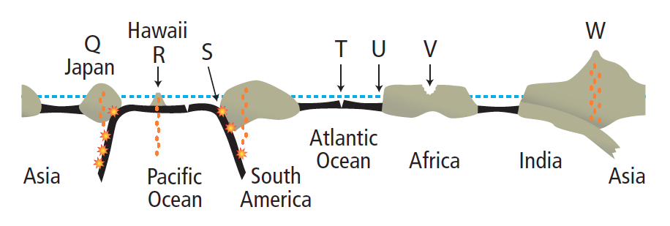

- Why do earthquakes and volcanoes occur at tectonic plate boundaries?

