1-3 Grade & Pitch Notes

New Skill: Working with Grade

Grade: the slope of a physical feature such as a road or hill, often expressed as a percentage

When talking about the slope of a road, it is usually called the road grade. Grade is commonly expressed as a percentage. The steeper the road, the higher its percent grade.

The following formula can be used to calculate grade.

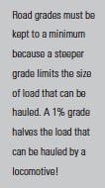
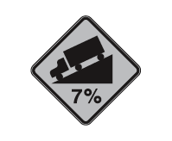
Example 1) Martin is driving his truck on the Trans-Canada Highway. There is a sign indicating a 7% grade.
a) What is the slope of the road, as a fraction?

b) Find the angle of elevation of the road.

New Skill: Working with Pitch
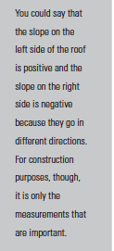
The slope of a roof is often referred to as its pitch. A roof with
a pitch of 5:8 is a roof with a rise of 5 and a run of 8, or a slope
of 5/8.

Example 2) How wide is the shed in the diagram below if the pitch
of the left side is 3:4 and the pitch of the right side is 8:9?

