1-3 Grade & Pitch Assignment

1. Heckman Pass is a very steep section of highway connecting Anahim Lake and Bella Coola, BC. At its steepest section, it rises 900 m over a run of 5 km. What is the percent grade of this section?

2. So that water will drain properly, a patio attached to a house should slope
downward about 2 ½ inches for every 10 feet of run. Calculate:
a) the slope; and

b) the percent grade.

3. One of the steepest railways in the world is the Lisbon tram in Portugal. In one section, it has a grade of 13.5%.
a) Express this as a slope.

b) Calculate the angle of elevation.

c) What is the rise for a run of 15 m?
9. The pitch of a roof on a lean-to that Dianna is building is 2:5. If the lean-to touches the ground 4.8 m from the base of the building, how high up the building does it reach?

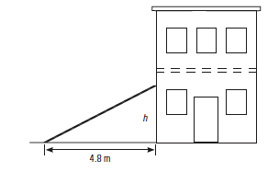

10. What is the pitch of the roof of an A-frame building if its height is 3.6 m and its width is 5.4 m?

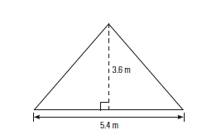
11. The roof of a tool shed has a pitch of 2:5. If the shed is 7 feet wide, what is the rise of the roof?

