1-2 Angle of Elevation Notes

Review: The Pythagorean Theorem & Tangent Ratio

In this section, you will work with the Pythagorean theorem and the tangent ratio.

The Pythagorean theorem states the relationship between the sides of a right triangle. In right triangle ΔABC shown below, the Pythagorean theorem states the following.

The tangent ratio is a trigonometric ratio that applies to right triangles. It is a ratio of the side opposite an acute angle to the side adjacent to the angle. For angle A, the ratio can be stated as follows.

This can be abbreviated as:

For triangle ABC shown above, tan A can be stated as:

Example 1) Use the diagram to calculate the following:
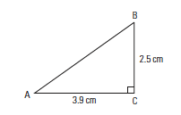
a) the length of the hypotenuse; and

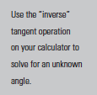

b) the measure of ∠A.

New Skill: Working with Slope & the Tangent Ratio

In section 1.1, you saw that slope is equal to the ratio of rise to run.
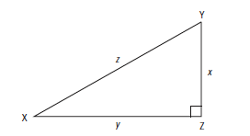

In the right triangle DXYZ, the slope of the segment z is the ratio of the rise, x, to the run, y.

The tangent of ∠X is the ratio of the opposite side, x, to the adjacent side, y.

∠X can be referred to as the angle of elevation of segment z. ∠Y is called its angle of depression.

Example 2) Find the slope of the hypotenuse as a fraction, and use it to find the angle of elevation.
