1-2 Angle of Elevation Assignment

1. In each diagram, calculate the indicated side using the Pythagorean theorem and find the indicated angle using the tangent ratio.
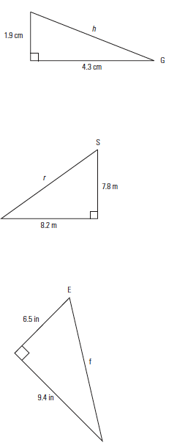
a)

b)

c)
2. Calculate the angle of elevation and the slope of the hypotenuse.

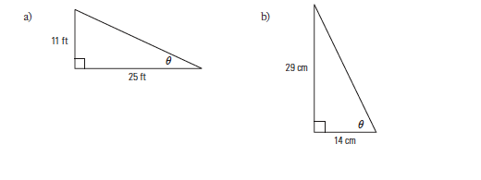

3. A ski jump rises 3 feet over a run of 7 feet.
a) What is the length of the surface of the jump?

b) What is the angle of elevation of the jump?
4. A driveway rises 2.2 m from the street level to the carport, which is a horizontal distance of 5.8 m from the street.
a) How long is the driveway?

b) What is its angle of elevation?

5. A wheelchair ramp is being built to rise to a landing that is 2.4 m above the ground. Building regulations say that the ramp can have a maximum rise of 2.5 cm per 30 cm of run.
a) What is the total run for the wheelchair ramp?

b) How long will the ramp be?

